METHODOLOGY AND EXPERIMENTS
Our dataset contains both text and numeric field, we can split the analysis into two different approaches such as Descriptive Analysis and Text Analytics.

Descriptive Analysis:
Firstly, I created an array from our posts for our analysis. Secondly, I have removed unnecessary symbols such as punctuation, tagging, special characters, URL etc. Thirdly, will remove stopwords using NLTK library and custom defined stopwords. At last, I normalize every word using NLTK library and finally I will get a group of filtered sentences, a corpus.

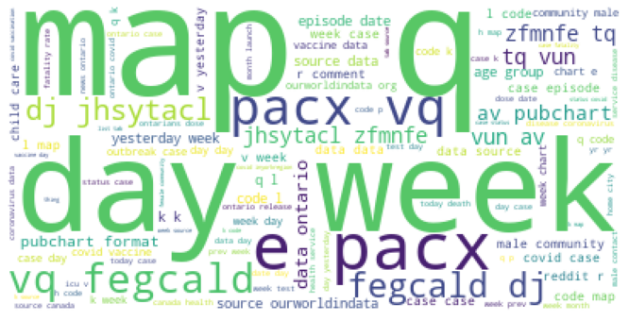
Figure 1: Word cloud of the posts

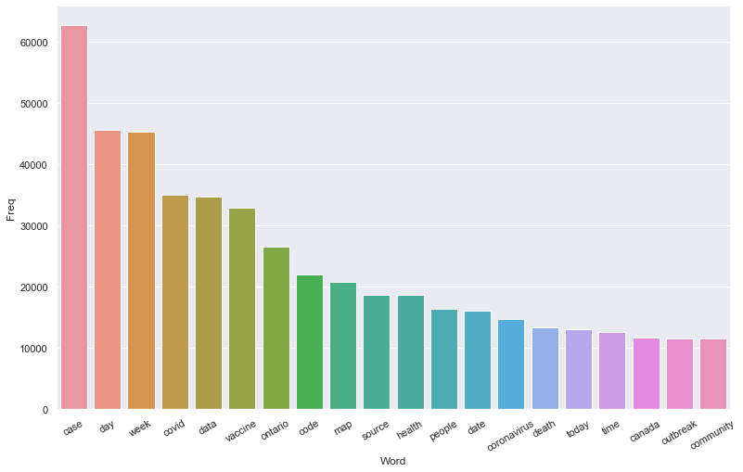
Figure 2: Top 20 Unigram of the posts

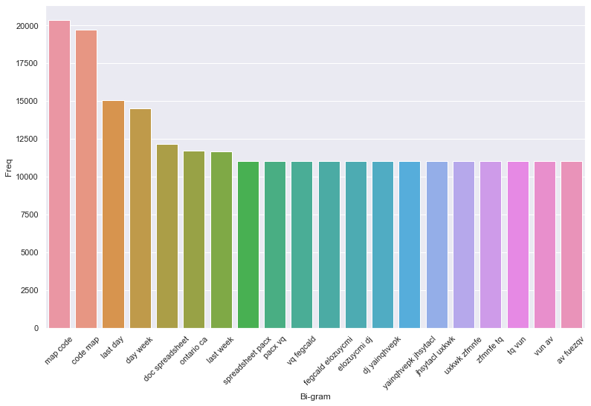
Figure 3: Top 20 Bigram of the posts

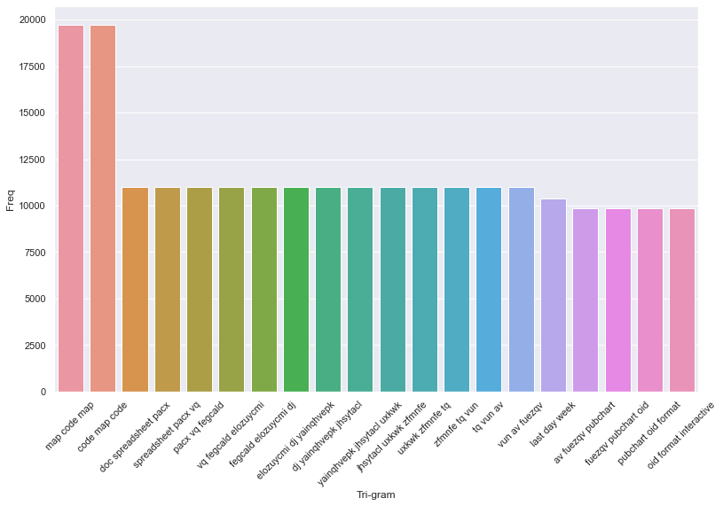
Figure 4: Top 20 Trigram of the post

Text Analytics:
Two coders independently coded the labels based on the posts and agreed upon the consensus to make the final decision for each post manually. Since it is a time taking process and involves intensive modelling, we would like to pursue this portion along the way for future work. We are proposing 1. Keyword Analysis, 2. Topic Modelling and 3. Domain Specific classifier modelling and would be using Multi-dimensional Text classification tool (MUTATO) for the same.

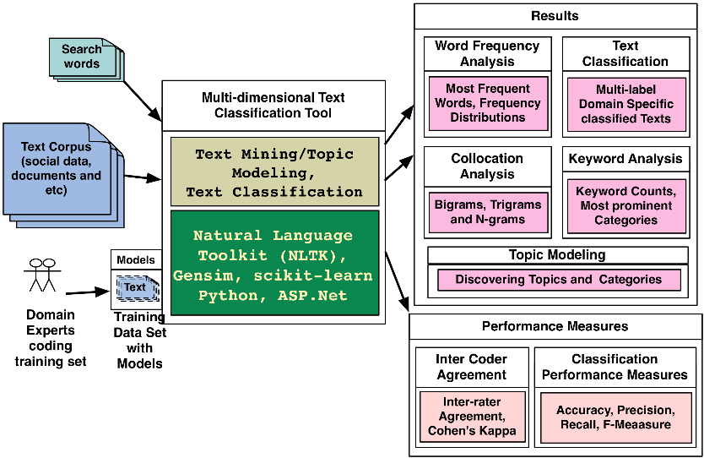

Proposed Labels are listed below:

Medical health => h / h-
Personal => p / p-
Social => s / s-
Conspiracy => c / c-
None => n

Sample doc is attached below for reference:

